**Project Planning Phase**

**Project Planning Template (Product Backlog, Sprint Planning, Stories, Story points)**

|  |  |
| --- | --- |
| Date | 20 NOVEMBER 2022 |
| Team ID | PNT2022TMID51748 |
| Project Name | Emerging Methods for Early Detection of Forest Fires |

**Product Backlog, Sprint Schedule, and Estimation (4 Marks)**

|  |  |  |  |  |  |  |
| --- | --- | --- | --- | --- | --- | --- |
| **Sprint** | **Functional**  **Requirement (Epic)** | **User Story**  **Number** | **User Story / Task** | **Story Points** | **Priority** | **Team**  **Members** |
| Sprint-1 | Registration | USN-1 | As a user, I can register for the application by entering my email, password, and confirming my password. | 20 | High | Abinesh.T  Abishek .A  Shahil b Raj  Sreejith |
| Sprint-1 |  | USN-2 | As a user, I will receive confirmation email once I have registered for the application | 20 | High | Abinesh.T  Abishek .A  Shahil b Raj  Sreejith |

|  |  |  |  |  |  |  |  |  |  |  |  |  |  |
| --- | --- | --- | --- | --- | --- | --- | --- | --- | --- | --- | --- | --- | --- |
| Sprint-2 | Input | | | USN-3 | | Whenever the fire is detected, the information is given to the database. | | | 20 | High | | Abinesh.T  Abishek .A  Shahil b Raj  Sreejith | |
| Sprint-2 |  | | | USN-4 | | When it is the wildfire then the alarming system is activated. | | | 20 | High | | Abinesh.T  Abishek.A  Shahil b Raj  Sreejith | |
| Sprint-3 | Output | | | USN-5 | | And the alarm also sent to the corresponding departments and made them know that the wildfire is erupted. | | | 20 | High | | Abinesh.T  Abishek.A  Shahil b Raj  Sreejith | |
| Sprint-4 | Action | | | USN-6 | | Required actions will be taken in order to controlled erupted wildfire by reaching as early as possible to the destination with the help of detecting systems. | | | 20 | High | | Abinesh.T  Abishek.A  Shahil b Raj  Sreejith | |
| **Sprint** | | **Total Story Points** | **Duration** | | **Sprint Start Date** | | **Sprint End Date (Planned)** | **Story Points**  **Completed (as on**  **Planned End Date)** | | | **Sprint Release Date (Actual)** | |
| Sprint-1 | | 20 | 5 Days | | 22 Oct 2022 | | 29 Oct 2022 | 20 | | | 29 Oct 2022 | |
| Sprint-2 | | 20 | 6 Days | | 01 Nov2022 | | 05 Nov 2022 | 20 | | | 05 Nov 2022 | |
| Sprint-3 | | 20 | 6 Days | | 10 Nov 2022 | | 16 Nov 2022 | 20 | | | 16 Nov 2022 | |
| Sprint-4 | | 20 | 4 Days | | 16 Nov 2022 | | 20 Nov 2022 | 20 | | | 20 Nov 2022 | |

**Project Tracker, Velocity & Burndown Chart: (4 Marks) Velocity:**

Imagine we have a 10-day sprint duration, and the velocity of the team is 20 (points per sprint). Let’s calculate the team’s average velocity (AV) per iteration unit (story points per day)

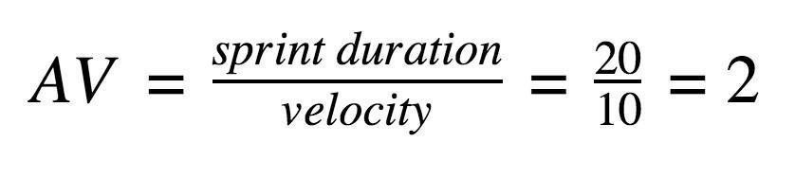

**Burndown Chart:**

A burn down chart is a graphical representation of work left to do versus time. It is often used in agile [software development met](https://www.visual-paradigm.com/scrum/what-is-agile-software-development/)hodologies such as [Scrum. Ho](https://www.visual-paradigm.com/scrum/scrum-in-3-minutes/)wever, burn down charts can be applied to any project containing measurable progress over time.